ODHS Task phase -3

Shashwat Harsh|220953028

🔴🔴🔴*TASK 3* 🔴🔴🔴

This task is to help you understand what are microcontrollers ,microprocessors and the difference between them. And also about clocks and timers in digital electronics.

1. Microcontroller

2. Microprocessor

3. Clocks and timers - learn about watchdogs, PLL, HSE, HSI

4. For the STM32F407VGT6, list the number of interfaces for i2c, spi, usart.

Make a single report on these topics.

Submit your reports as pdf or word only to parikshit.odhs@gmail.com

Deadline: 14th November 2023,time: 23:59

# Microprocessors

A CPU built on a single IC is a micro processor.

It is general purpose i.e. task is not defined and requires additional components( like:- clock source, memory(ram, rom ), BUS system, I/O devices etc) to function which are connected externally and thus cannot be used independently.

Works on von Neumann architecture??

It uses the Fetch- Decode- Execute cycle.

It contains :-

### Arithmetic and logical unit (ALU)

performs arithmetic operations (addition, subtraction, multiplication, division) and logical operations (AND, OR, NOT) on data. It handles mathematical calculations and comparisons.

### Control Unit (CU)

execution of instructions

It fetches instructions from memory, decodes them

### register array

small high speed storage

holds data temporarily during processing

It is general purpose and requires additional components to function and thus cannot be directly used.

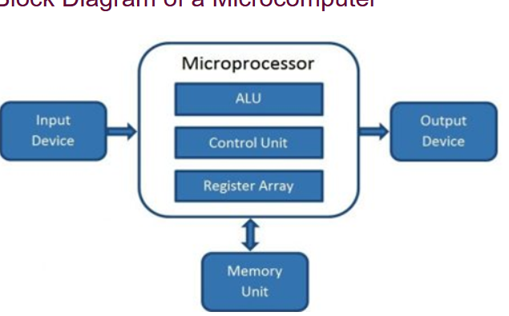

Resources:-

<https://computer.howstuffworks.com/microprocessor.htm>

<https://www.javatpoint.com/microprocessor-introduction>

<https://www.tutorialspoint.com/microprocessor/microprocessor_overview.htm>

<https://www.youtube.com/watch?v=TJzSHAtslyQ>

<https://www.youtube.com/watch?v=Z5JC9Ve1sfI>

# Microcontrollers

These are a micro computer on a single integrated circuit that is designed to do a specific task.

It combines the functions of a CPU, memory, I/O ports, on a single IC.

Works on Harvard architecture??

They are used in wide range of embedded systems such as:-

Security systems

Laser Printers

Automation System

Washing machines etc

Resources:-

<https://www.geeksforgeeks.org/microcontroller-and-its-types/>

<https://www.tutorialspoint.com/microprocessor/microcontrollers_overview.htm>

# Microprocessor vs Microcontroller

|  |  |  |
| --- | --- | --- |
|  | Microprocessor | Microcontroller |
| Memory | Requires external memory and data storage. | On-chip memory modules (ROM, RAM). |
| Peripherals | Needs additional parts. Connect with the external bus. | On-chip peripherals (timers, I/O ports, signal converter). |
| Computational capacity | Capable of complex computing tasks. | Limited to specific application logic. |
| Clock speed | Very fast. GHz range. | Fast but slower than microprocessors. kHz to MHz range. |
| Power consumption | High power consumption. No power saving mode. | Consumes minimal power. Built-in power saving modes. |
| Operating system | Requires operating systems. | Operating system is optional for some microcontrollers. |
| Connectivity | Handles high-speed data transfer. Supports USB 3.0 and Gigabit Ethernet. | Supports low to moderate speed communication. Serial Peripheral Interface (SPI) and I²C. Universal asynchronous receiver-transmitter (UART). |
| Cost | Expensive because of the additional components. | Cheaper because a single integrated circuit provides multiple functionalities. |
| Use case | For generic computing, or systems requiring robust computational capacity. | For compact systems, battery-powered, or logic processing devices. |

Resource:-

<https://aws.amazon.com/compare/the-difference-between-microprocessors-microcontrollers/>

<https://www.youtube.com/watch?v=dcNk0urQsQM>

# Clocks and timers - learn about watchdogs, PLL, HSE, HIS

Clocks and timers generate precise timing signals that are used to synchronize the operation of various peripherals in the system.

## Clocks

It is a signal that is used to synchronize the operation of all the components in the system.

It is generated by an oscillator and is used to provide a reference for all the timing signals in the system.

The clock signal is used to determine the rate at which instructions are executed and data is transferred between components.

## Timers

It is a peripheral that is used to generate timing signals for specific tasks.

Generally used to generate delays, measure the duration of events, or generate periodic signals. Also used to control the operation of other peripherals in the system. Like:- ADCs, DACs, and PWMs.

## Watchdog timers

These are simple countdown timers used to reset a microprocessor /microcontroller after a specific interval of time.

The software will periodically "pet" or restart the watchdog timer. After being restarted, the watchdog will begin timing another predetermined interval.

When software or the device is not functioning correctly during program flow, software will not restart the watchdog timer before it times out.

When the watchdog timer times out, it will cause a reset of the microcontroller. If the system software has been designed correctly and there has been no hardware failure or data corruption, the reset will cause the system to operate properly again.

It cannot detect a fault instantaneously. Must time out to detect fault.

If there is a data corruption in memory, the resetting of the processor by the watchdog will not make the program function properly.

## PLL

Phase locked loop

It is a feedback control system that generates an output signal whose phase is locked to the phase of an input signal.

Used to generate a stable and precise clock signal from a less accurate reference signal.

The reference signal is fed into the PLL, which compares it to a feedback signal generated by a voltage-controlled oscillator (VCO).

It then adjusts the VCO’s frequency until the feedback signal matches the reference signal in both frequency and phase.

This results in a stable and precise output signal that is locked to the reference signal.

Used to generate high-frequency clock signals from low-frequency reference signals. Eg:- 100MHz from 10MHz clock signal .

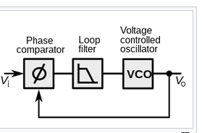

## HSE

High speed external

It is an external clock source that is used to generate high-frequency clock signals in microcontrollers.

Used along with PLL to generate high frequency clock signal from low frequency signal.

external clock source such as HSE is preferred over an internal clock source such as HSI because it provides better accuracy and stability.

The external clock source is usually a crystal oscillator that is designed to operate at a specific frequency.

The frequency of the external clock source is then multiplied by the PLL to generate the desired high-frequency clock signal .

## HSI

High-Speed Internal

These are internal clocks present on a microcontrollers.

It has shorter startup time and generally serves as default clock during boot time while/before PLL or HSE are configured.

Used when precise timing is not critical.

Limited frequency range compared to external clocks.

However is convenient to use are readily present and when there is space constraints.

Resources:-

<https://www.youtube.com/watch?v=HOfMYxm888Q>

<https://www.analog.com/en/technical-articles/using-the-secure-microcontroller-watchdog-timer.html#:~:text=A%20watchdog%20timer%20is%20a%20simple%20countdown%20timer%20which%20is,begin%20timing%20another%20predetermined%20interval>

<https://www.analog.com/en/analog-dialogue/articles/phase-locked-loop-pll-fundamentals.html>

<https://electronics.stackexchange.com/questions/134684/why-use-stm32-hse>

<http://www.learningaboutelectronics.com/Articles/HSI-vs-HSE-clock-in-an-STM32F4xx-microcontroller.php>

# number of interfaces for i2c, spi, usart in STM32F407VGT6

for STM32F407xx family ICs

there are :-

Up to 3 × I2C interfaces (SMBus/PMBus)

Up to 4 USARTs/2 UARTs (10.5 Mbit/s, ISO 7816 interface, LIN, IrDA, modem control)

Up to 3 SPIs (42 Mbits/s), 2 with muxed full-duplex I2S to achieve audio class accuracy via internal audio PLL or external clock

For STM32F407VGT6 there are 3 * I2C, 3* SPI and 3* USART and 2* UART interfaces

Resource:-

<https://www.allaboutcircuits.com/electronic-components/datasheet/STM32F407VGT6--STMicroelectronics/>

<https://forum.micropython.org/viewtopic.php?t=3086>